Holiday Boredom Busters

How many different words can you make from the letters in this sentence, below?
Grab a pencil and paper and write a list!
‘Learning from home is fun’
Thank a community hero such as a nurse, shopkeeper etc
Think of someone that helps you in some way and write a short letter to thank them.
Get building! You could build a Lego model, a tower of playing cards or something else!
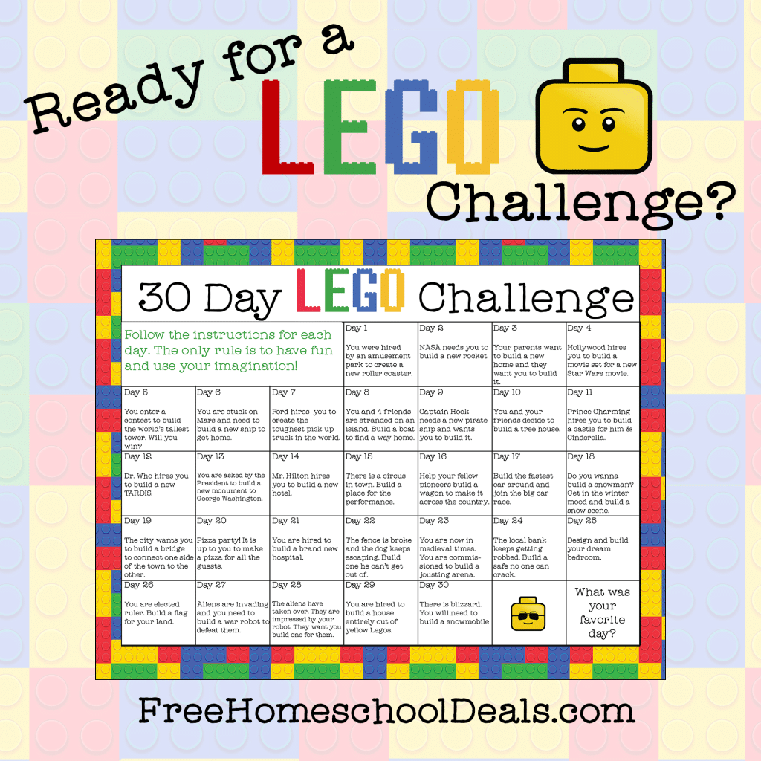

Can you create your own secret code?
You could use letters, numbers, pictures or something else! Can you get someone else to try and crack it?
Start a nature diary.
Look out of the window each day and keep note of what you see. Birds, flowers, changes in the weather, what else?
https://www.woodlandtrust.org.uk/blog/2020/03/kids-nature-activities-self-isolation/
Hold a photo session.
Use a camera, tablet or a mobile phone to take some snaps. What will you photograph? Your pets or toys perhaps?
Build a reading den.
Find somewhere cosy, snuggle up and read your favourite book!
Use an old sock to create a puppet.
How to make a sock puppet
Can you put on a puppet show for someone?
Design and make a homemade board game and play it with your family.
Do something kind for someone.
Can you pay them a compliment, make them something or help them with a task?
List making!
Write a list of things that make you happy, things you’re grateful for or things you are good at.
Design and make an obstacle course at home or in the garden.
How fast can you complete it?
Can you invent something new?
Perhaps a gadget or something to help people? Draw a picture or write a description.
Keep moving!
Make up a dance routine to your favourite song.
Write a play script.
Can you act it out to other people? Video and show others.
Get sketching!
Find a photograph or picture of a person, place or object and sketch it.
Junk modelling!
Collect and recycle materials such as yoghurt pots, toilet rolls and boxes and see what you can create with them.
https://www.playlikemum.com/20-genius-junk-modelling-ideas-for-kids-to-try/
Write a postcard to your teacher.
Get Baking!
https://www.bbcgoodfood.com/recipes/collection/kids-baking
Get Growing
Growing food from kitchen scraps
Join a choir
https://decca.com/greatbritishhomechorus/
Draw a view. Look out of your window and draw what you see.
Get reading! What would you most like to learn about? Can you find out more about it in books? Perhaps you can find a new hobby?
Learn to Type
https://www.kidztype.com/
